**The Role of Al-Khairat Scheme as Part of a Micro Takaful Program for Funeral Funding Purposes; Malaysia Case**

Achmad Firdaus1

Erwita Triana Dewi2

1,2 Institut Agama Islam Tazkia

1achmad.firdaus@tazkia.ac.id

2Erwita.Dewi@bni-life.co.id

**Abstract**

1. **INTRODUCTION**

Some part of Muslim community through the mosque have come together to raise funds for the purpose of financing their funeral expenses in Malaysia. The fund collected may be through monthly or yearly contributions. The fund is kept in an account and only will be used in the event of died of the members of the community; to cover expenses such as grave digging, transportation back to their village, etc. This scheme is known as the *al-khairat* scheme.

The implementation of the scheme is to serve as an ongoing effort to ensure that the group member is psychologically safe and their welfare is taken care of. At the same time, the focus of cooperative such as the yayasan masjid is to provide assistance to ensure that the family could continue their lives based on the continuing resources from their business activities.

Death is one form of ordeal given by Allah SWT to every human being. The ordeal is carried out on one of five basic human needs (maslahah daruriyah) consisting of: (i) the religion, (ii) life, (iii) progression, (iv) intellectual and (v) wealth. The death is a ordeal to humans in meeting the needs of the soul.

Allah SWTorders us to work together (Ta’awun) in virtue and piety, and forbid from mutual worship in sin and hostility. In the Holy Quran the spirit of cooperative in its teachings in Surah Al-Ma’idah/5: 2, *“Help (ta’awun) yet one another in righteousness and piety, but help ye not one another in sin and rancour, fear Allah, for Allah is strict in punishment”.*

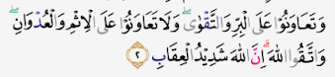

Ibn Kathir explained Allah Ta'ala who asked His servants who believed to always help one another in righteousness called al-birru (benevolence), as well as leaves all forms of renege, and that is called at-taqwa. One form of *al-birru* is helping families/relatives who are being overwritten by the ordeal in the form of death.

The existing form of Khairat Kematian, in terms of features and functions has been managed by several Yayasan Masjid in Malaysia. The Khairat scheme as a measure to assist family members of the target group in terms of their welfare and entrepreneurial development in continuing with their lives after the loss of the head of their family.

The average cost of a Muslim burial in Malaysia is around RM 1,400. Most of participant those who sign up for khairat kematian not only help themselves, they also help other members of the community who can't afford a funeral. Many Muslims burial service organisations have this Khairat Kematian scheme. It is encourage in Islam - to support one another. The Benefit of khairat scheme will relieve on every muslim. They no longer have to worry about what will happen when pass away because everything is settled. These schemes are carried out by Muslim burial service organisation which also covers spouses.

The Khairat scheme is very beneficial for the community considering that Malaysia has an aging population of around 6,9% of the population aged over 65 years and there is pressure on economic old-age dependency ratio (economic OADR) around 12,6%. The economic OADR is defined as the effective number of consumers aged 65 years or over divided by the effective number of workers at all ages; which means that there is one dependent for every 12,6 adults. With fewer children to support the older generation, life needs and health care will increase (UN, 2019)[1]. The expenditure of out-of-pocket (OOP) health services in the Malaysian population accounts for about 36% of total expenditure, this shows a relatively high number compared to most neighboring countries

Malaysia is currently grappling with a low level of insurance penetration, even though one third of Malaysia's population has a life insurance coverage, as much as 90% are considered under insurance.

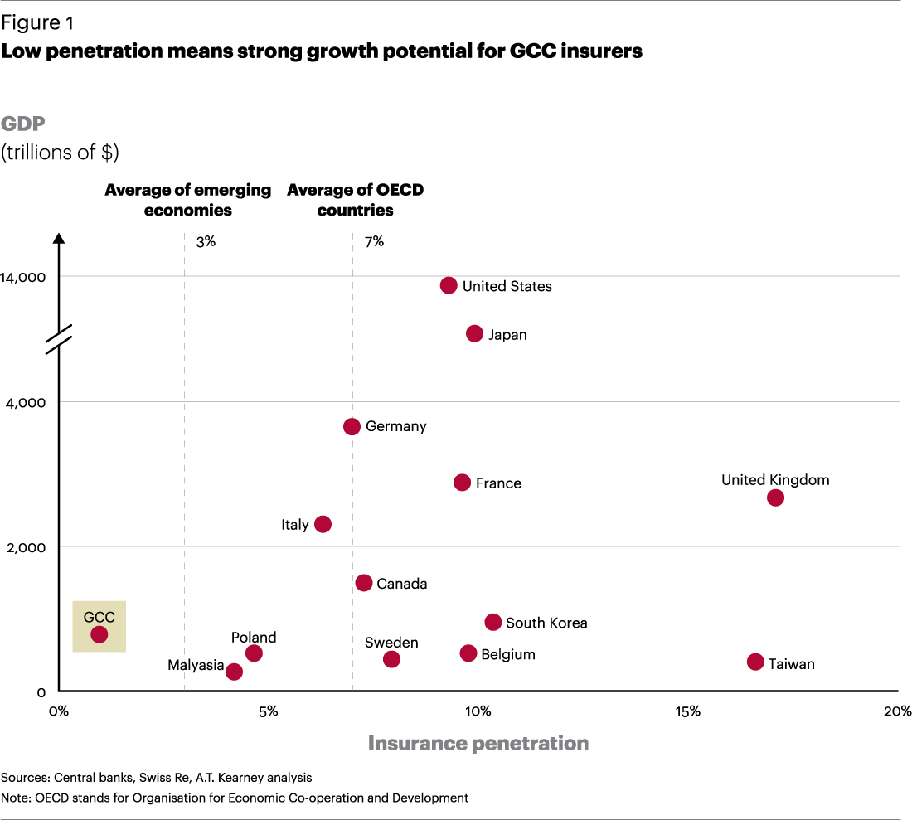

The industry penetration rate of insurance is based on the premium value relative to gross domestic product, reaching 3.1%, lower than Organisation for Economic Co-operation and Development (OECD) countries average of around 5%, but better than Indonesia the new penetration only reaches 1.14% (Pock, 2010).[2]

The Objective of this paper is delivering the discussion of the benefit of micro-takaful to the society, particularly for the lower income group, the challenges in developing and sustaining micro-takaful schemes dan how the concept of the khairat scheme above can be integrated in the micro-takaful concept.

# LITERATURE REVIEW

Micro Takaful is considered an important incentive for the protection and financing of micro enterprise and low income families. It encourages banks to finance micro enterprises. Micro Takaful mainly supports protecting micro enterprises by using Micro Takaful to aid in financing these enterprises which results in higher return on investment and growth in developing countries (Arun and Steiner, 2008)[3].

Micro Takaful provides the availability to finance catastrophe victims and supporting micro enterprises mainly in agriculture industry, the people living in isolated areas or in difficult living circumstances by supporting them in facing the risks as an effective tool for facing poverty. The main benefit of Micro takaful in its implementation is carrying out the religion of Allah **سُبْحَانَهُ وَ تَعَالَى** by manifesting Ta'awun's in virtue and piety which will bring good to the Muslim community and the safety of the ugliness and consciousness of the individual of the role of responsibility. Because Ta'awun in the life of the ummah is a manifestation of personality and is the foundation in fostering the life of the people.

In the Saheeh of the hadith narrated by Muslims of Tamim ad-From Rishayallahu 'anhu he said, *the Prophet* Rosullulah ﷺ *said: "Religion is advice", he was asked: "For whom O Messenger of Allah? ", The Messenger of Allah replied:" For Allah, His Book, His Messenger, Muslim leaders and the general public.* ". An-Nushhu is devoting himself to something without being accompanied by deception and betrayal. This is the obligation of the Muslims as caliphs in explaining the truth, preaching to Allah سُبْحَانَهُ وَ تَعَالَى , being patient with all obstacles and carrying out all difficulties. Allah **سُبْحَانَهُ وَ تَعَالَى**  say:

Top of Form

*"Who is better than those who call on God, do righteous deeds, and say:" I am among those who surrender themselves?* " [QS Fushshilat/41: 33]

1. The practice of micro takaful is giving the financial advice and benefit for society. Whoever leaves advice to his brother and abandons him, in essence he is a deceiver and not their defender. Because it is a consequence of loyalty is advising and helping them in virtue and piety. Ta'awun in micro takaful is to realize the consequences of attitude wala '(loyalty) to the Muslims according to the word of Allah سُبْحَانَهُ وَ تَعَالَى in Quran Surat At Tawbah / 9: 71

*And those who believe, men and women, part of them become helpers for others. They sent (to do) those who understood, prevented from the evil, established prayers, performed zakat and obeyed Allah* سُبْحَانَهُ وَ تَعَالَى *and His Messenger. They will be given mercy by Allah* سُبْحَانَهُ وَ تَعَالَى ; *surely Allah is Mighty, Wise*.” [QS At-Taubah/9: 71]

2. **Ta'awun among Muslims is a strength and protector**. The Prophet Rosullulah ﷺ has likened the ta'awun of the Muslims, their unity and clinging to them (to the religion of Allah سُبْحَانَهُ وَ تَعَالَى ) with buildings built with neatly arranged bricks that add to their strength. Thus the Muslims, getting stronger with mutual help help between them. As said by the Prophet Rosullulah ﷺ "*A believer with other believers is like a building which partly strengthens the other parts.*" It is not these Muslims who are weak and their enemies dominate them, but because of their divisions and disputes, even though their quantity and number are many. This case is something that has been known by a straight forward nature and is known by a healthy mind, the sentence of monotheism is the foundation of the unity of the Ummah

3. **Micro takaful Ta'awun provides the benefits of ittihad (unity) to uphold virtues** and piety in the face of the earth, to deliver the power of the Muslims in safeguarding Maqashid Syariah, As the word of Allah **سُبْحَانَهُ وَ تَعَالَى** "*Truly (religion of Tauhid), is your religion all, one religion, and I am your Lord, then fear Me." [QS Al-Mu'minun / 23: 52] and [QS Al- Anbiya / 21: 92]*. The consequence of not enforcing unity will lead to severe weakness, the power of the enemies above Islamic law, as reported in the hadith of the Prophet Rosullulah ﷺ: "*You are almost contested by the people other than you as food in a jar contested by humans." The Companions asked: "What is our number at that time a little O Messenger of Allah?" The Prophet sallallaahu 'alaihi wa sallam replied: "Even your number at that time is many, but you are like foam, and Allah will raise fear of you from the enemy chest - Your enemies, and Allah will put al-Wahn into your hearts. "The Companions asked:" Is al-Wahn O Messenger of Allah? ", the Prophet replied:" Love the world and fear death.* "

This hadith suggests that the weaknesses of the Muslims today are in weaknesses even though there are many in number, but they are scattered, walking without direction and moving aimlessly, so Allah سُبْحَانَهُ وَ تَعَالَى imposes upon them the humiliation that will remain in the longitude and latitude of this earth. As the Prophet Rosullulah ﷺ  said: "*If you have been busy with buying and selling inah (buying and selling systems that have elements of usury, pent.), You are lulled by livestock and farming, and you leave jihad, then* Allah سُبْحَانَهُ وَ تَعَالَى *will impose above you humiliation that will not be lifted until you return to your religion.* "[Hadith Sahih History Abu Daud]

Based on the hadith above, the Muslims must have solidarity with their siblings, feel their pain, please help so that Muslims can become a living body, as the Prophet sallallaahu 'alaihi wa Salam said: "The parable of the believers in love, affection and tenderness is like one body, if one of the limbs complains it will call all other limbs awake and fever. "[Muttafaq 'alaihi]

The divisions are the motto of the polytheists who will make a tribe of tahazzub (parties) and tafarruq (classifications). Allah سُبْحَانَهُ وَ تَعَالَى denounces tafarruq (division), because the division removes ta'awun (cooperation), passion (heart), love, and delivers to disputes, sadness and hatred according to the word of Allah **سُبْحَانَهُ وَ تَعَالَى**  in Sura [ar-Rum / 30: 32

Namely those who divide their religion due to their disputes in what they worship (and they become several groups) become religious sects. (Each group) from among them (with what is in their group) means what is in themselves (feeling proud) that is to be proud of. faraquu means they abandoned the religion they were ordered to carry out. [QS Ar-Rum/30: 32]

***4. Micro Takaful carrying out the mission of Tawaashi (mutual witnes***s) in truth and patience is the cause of salvation from loss. Mutual witnessing in truth and patience includes real manifestations of ta'awun syar'iy in virtue and piety. With these two things, the religion of Allah سُبْحَانَهُ وَ تَعَالَى will be preserved, and including amar ma'ruf nahi munkar, is the cause of the goodness of the country and its inhabitants in Holy Quran Surat [QS Al-Ashr/103; 1-4]

The manifestation of ta’awun will eliminate the troubles of the Muslims, close their disgrace, facilitate their affairs, help them from those who do persecution, help with the calamity that befell them, support their jihad and da'wah, visit people who are sick, fulfill invitations, deliver bodies, and help them in all good things.

Mikro Takaful Ta'awuni is expected to bring people mutual tolerance and eliminate fanaticism in community groups, eliminate feelings of hostility and hatred among humans, racial and religious differences, because they interact with the principles of humanity and brotherhood ukhuwah imaniyah (brotherhood of faith) invites to the good and and prevents actions that harm other people in accordance with the teachings of each religion.

The development of the Micro Takaful Insurance industry requires the support of the development of the micro Takaful financial business, as a positive indicator of the availability of protecting low income households, saving their investments in an economical way, and supporting social security networks and bringing social responsibility. Currently Islamic banking is the biggest contributor to the Islamic Financial Industry, which accounts for 80% of the total Islamic finance industry valued at $ 2.3 trillion, while Sukuk accounts for 14% of the volume in the Islamic Finance industry and ranks second as the biggest contributor, Islamic Fund / Asset Management Industry with 3% ranked 3rd while Takaful Industry contributed 2% with slow speed and Islamic Microfinance contributed 1% as the last. In 2017, the total volume of the Islamic Financial Industry is estimated to have reached USD 2.7 trillion.[4]

Figure 3. Islamic Microfinance Industri in Global Islamic Market

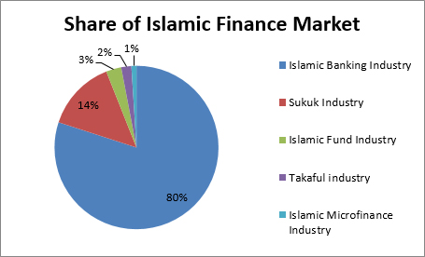

Bank Negara Malaysia, together with the insurance industry, was introduced an affordable insurance scheme called "Perlindungan Tenang" in November 2017[5]. Riding on the three basic criteria of affordability, accessibility and simplicity, the objective of the scheme is affordable insurance / takaful offerings to cover the financial protection needs of the bottom 40% of households low income, due to some communities cannot afford insurance altogether. Micro Insurance provides temporary financial relief to low-income households to help them cope with a sudden loss of income due to illness, accidents or death, with the condition that the registrants must be employed. The other benefit covering housing expenditures and food needs, also provides family breadwinner passes away.

1. **RESULT AND ANALYSIS**
2. Challenges in Developing and Sustaining Micro-Takaful Schemes

Micro takaful products as mass products face challenges in this era including the selection of simple and efficient marketing and sales distribution channels reaching the public, digital infrastructure and communication and new business infrastructure, this formative market strategy tries to build specific product formations of itself. Challenges in the khairat scheme that allow people to make regular prepayments to group funds to ease the burden on families who cannot afford to pay it. Khairat Kematian is a scheme where people can register to ensure that their last cremation ceremony will be carried out without complications. All necessary procedures, such as prayer, bathing, embalming and even transportation to the cemetery, will be included. It operates on the principle of mutual benefit where the distribution of the largest channels currently is agents and bancassurance (Figure 4) is the dominant marketing channel in Malaysia[6].

Figure 4 Channel Distribution chalange Micro Takaful Insurance

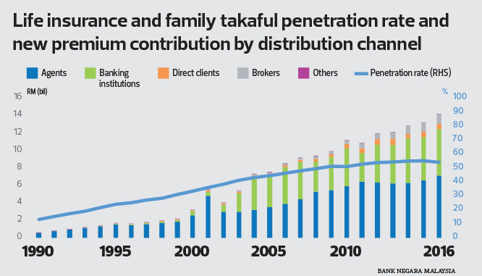

The Khairat scheme managed mostly by mosque administrators, has several challenges that must be understood by stakeholders, namely the obligation to maintain continuity of business cooperation and solidarity, management is required to operate funds professionally so that they not only seek profit in managing tabarru’ funds, but also to compensate losses that have befallen its members and other members who are less capable. The procedure and management of micro takaful in a mosque foundation or committee include the following:

1. Estimating the mortality rate calculation as the basis for calculating the risk to compensate for the losses that have befallen its members, and to collect contributions to fulfill compensation (insurance) when the risk occurs, as determined
2. The agreement of a group of people to make a shunduq (place to collect funds), which they fund in certain installments paid from each member. Each member takes from the shunduq a certain part (instead, coverage) if a certain loss (danger, risk) is affected. Contributions are made into the risk pool. From this pool, direct and indirect expenses and claims are paid. If there is a surplus, it is shared amongst the participants. Deficits are also made up with additional contributions from participants or with an interest-free loan from the operator.
3. If the collected part (the company) has a surplus after the coverage is issued, the member has the right to request a return. And if there is a shortage, the members are asked to pay additional contributions to cover their shortcomings according to the inability. In practice this is difficult to implement given the limited micro takaful infrastructure in reaching information to all its members.
4. Requires advertising as a means of forming a brand image so that people create a culture of ta'aawun as a fundamental noble goal of helping one another, bearing collective calamity that befell some of its members and not merely as profit-seeking trade. The management of the mosque acts as an agent for the takaful operator and will also explain the contract of contract that does not contain usury, speculation, maisir, gharar and gambling as basic Takaful principles.

Figure 5 Core Ingredients Micro Takaful Insurance[7]

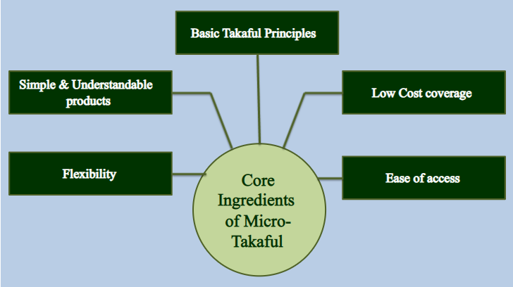

a. In the practice of khairat scheme, one family or a number of people make a shunduq, then they give up some money, which later, from the amount of money collected is used for compensation (as insurance) to members who get disaster (danger, risk). If the money collected does not cover it, then adding contributions covers the shortfall. If there is excess after being compensated, then it will be returned to each of its members, or used as capital for the future.

b. The implementation of the Khairat scheme has been managed by an institution or foundation by having officers who specifically regulate it to get and save donations, and publish it. This institution may also have a manager who makes plans and work arrangements. The following workers, officers and managers received Ujroh, but all must be based not for business profits, and all parties aim to help each other.

Ta'awun insurance develops in groups that have special relationships such as kinship or one job (profession). Takaful does not only cover the needs of Muslims, but for rahmatan lil alamin. Micro takaful globally is an ethical information structure of the principle of justice and sharing the burden of one another, extending protection to disadvantaged members of society.

The fundamental principle of Islamic economic system is the distribution of wealth fairly, its implementation has been regulated in Islamic inheritance law to regulate the shift and distribution of wealth, which is divided into various types of beneficiaries, Candidates in family takaful are guardians and money policies need to be distributed to all heirs. With takaful schemes, financial responsibility is shared with each other. It provides reciprocal financial assistance and members of the takaful scheme. This comes from the concept of collective division of individual losses.

Micro Takaful can be managed in a profit-sharing business between Operators and individual members of a group of participants who want to guarantee each other against certain losses or damage that might be caused. Sharia insurance cooperation contracts are based on mudarabah principles or limited partnerships, which means sharing of profits and losses. The excess or deficit of takaful surgery must be shared by the participants, or members themselves. In accordance with the agreement if the takaful scheme is operated commercially, the surplus mudarobah will be divided between the management operator (mudharib) and the participant (shahibul maal) in accordance with the mudarabah principle.

The tabarru contract in the Ta'awuni takaful scheme means that the participant will agree to release a number of takaful contributions to fulfill their mutual obligations and mutual guarantees, if there are fellow participants who suffer losses. This Tabaru concept still requires ongoing and challenging literacy so that the community does not feel the loss of money in monthly or annual contributions, but the entire fund is used for ta'awun humanity.

Management of micro takaful upfront costs is more efficient because the retail business is relatively simpler and can be transacted immediately on a small scale and in a large number of businesses. In this way, risk is limited and costs can be predicted. The challenges of Micro Insurance will be faced with the management of recording real-time manual database tabulations. The challenge of the Micro Takaful operator requires a small investment of simple software, hardware, and IT skills that the system is ready to use.

Surplus in Micro takaful can be used for zakat and humanitarian funds that can be channeled into common good projects in one region that may not all have Muslim populations. The principles of justice and sharing of burdens will undoubtedly provide protection to disadvantaged members of society, both Muslim and non-Muslim. The challenge for micro takaful Taawuni is to spread the spirit of humanity based on the principles of justice, transparency, simplicity and sharing of burden. On the basis of this ethical dimension, takaful will succeed, because it will certainly succeed (Ferguson, 2008). The takaful business has an explicit ethical structure that can be marketed to both Muslims and non-Muslims. The dramatic increase in takaful insurance demand can be attributed to the ethical nature of this product.

Sharia schemes are expected to operate fairly and in sharia in handling deductions from participant contributions. The ability to separate tabular funds for each class or business sub-class and the inherent ability to manage risk in real time can provide great benefits if managed honestly and responsibly. The challenge of managing micro takaful management requires personnel who understand the insurance business that is related to the free from elements of usury and other prohibited elements available from mudarabah, tabarru, and other elements justified by Shari'ah.

Participants and operators and participants in the Micro Tafaful scheme must equate their intention that modern micro takaful practices are similar to the insurance industry in the normal amount for a number of specific benefits. Through participation in takaful schemes, participants bring a humanitarian mission to help one another. Takaful operators are responsible for collecting as much funding as possible to help participants and non-participants who are in the same or adjacent location, who need humanitarian assistance.

The biggest challenge facing the takaful industry today is the misconception that takaful insurance is not specifically for the welfare of the Muslims, but for the welfare of all people, as a manifestation that Islam is rahmatan lil alamin. With multi-racial populations in Indonesia or Malaysia, non-Muslim communities have attracted interest among non-Muslims, despite clear religious and cultural differences.

It still needs comprehensive education and literacy on the interests shown by non-Muslims and Muslim support, to increase awareness of the benefits offered by micro takaful products. Gap gap on the awareness of both parties in bringing together benefits and perceptions, requires a bridge of education for micro takaful development to face challenges in the country and globally.

The current micro takaful challenges are financial strength, stability, and standards for insurance companies set and known. This conventional insurance has been in the industry for years and their level of service is clearer than takaful operators. To overcome this problem, various takaful products must be offered as alternatives to those offered in conventional markets. Low income groups must also be overcome. Mikro-takaful, a concept of providing affordable cover for the poor, comes to mind.

The micro takaful business engine is not just to make money, the main intention is to share his wealth through donating money or giving money to funds used to help other people who need help. He must look beyond worldly appreciation in the knowledge that when the time comes to face death, the takaful operator who manages the funds will also lighten the burden on his family in the same way when he acts against others in the same situation. The aim is to achieve prosperity in the life of the world and the hereafter. The relationship between social schemes in micro takaful practices according to Islamic scholars is an alternative that can be accepted by fulfilling sharia principles. Islam promotes cooperation and sharing.

The role of the digital revolution has provided ease of communication and transactions to support business enhancements for the banking industry given the familiar community with mobile banking transactions. In insurance technology companies become the main enabler besides human resources as the driving force of business growth. Insurance companies must further improve business process innovation, productivity, and learn digital analysis of customer experience profiles. The scheme's value as mass product insurance will be easier to penetrate if the customer's life cycle can be reached with the ease of simple digital technology, such as e-submission solutions, shorten the process of submitting claims and supplementing agencies with needs-based interactive applications for planning life goals that can accessed by customers while giving them new and innovative ways to provide consultation with increased efficiency, with the limited budget of each individual that will be spent in the insurance budget portion.

The synergy of the role of the government and insurance companies in Malaysia in developing Micro Takaful, can encourage the Khairat scheme to become a superior product to encourage economic growth by taking into account the following:

1. Market Needs The Khairat scheme, demand-driven products are a prerequisite for success and are a basic need, because every soul will feel dead, and the main grip target is a group with target financial resources limited or categorized as low income.
2. Simple product design, to keep its contribution affordable, only a large insurable risk must be borne by a relatively small benefit package. Group policy must be offered rather than covering individuals, to avoid 'anti-selection'.
3. Contributions, amounts must be commensurate with the cash flow of the participants, ideally, premiums must be associated with existing financial services,
4. Processes, application policies and claim documentation are reduced until minimum claims are quickly resolved
5. Distribution, the current network of schema literacy distribution networks from partners must be empowered and used because they know the target market well and have an established relationship with the existing community.
6. Market awareness, market education is the essence of creating awareness and the availability of micro takaful, to generate a spirit of mutual cooperation
7. How The Concept of the *Khairat* Scheme Above Can Be Integrated in The Micro-Takaful Concept

The Islamic financial system has various instruments and microfinance products that are in accordance with the norms in Islamic finance such as the prohibition of mayshir, gharar and usury, to protect against risks that cannot be predicted by borrowers.

The takaful micro concept in general is a mutual guarantee of the contribution of each member to an insurance fund managed optimally to increase prevention of risks and strengthen the security of borrowers. The Tabarru’ Fund 'is a reserve to compensate borrowers who face emergencies - such as fires, floods, agricultural losses and deaths - that affect their business. Premiums will be invested in the Islamic capital market or in the halal value chain business to provide a tabarru 'fund management surplus.

Figure 6 Khairat Scheme Simple Contributon

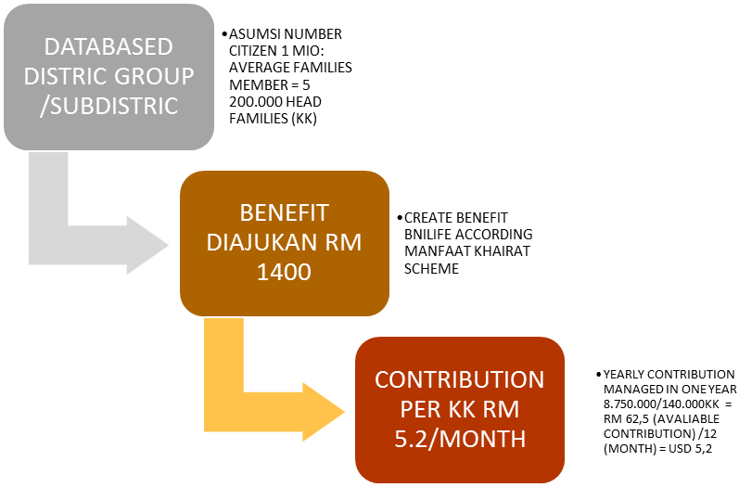

NUMBER FAMILIES THAT ARE ABLE TO PROVIDE TA'AWUN CONTRIBUTION = 70% (140,000KK) ASSUMPTIONS, 30% OF POVERTY LEVELS ARE INCOME FAMILY NOT ABLE TO

ASSUMPTION MORTALITY RATE = 5 ‰ x 1 MILLION x RM 1400 = RM 7 MIO GROSS CONTRIBUTION / (1-UJROH (20%)) = RM 8,750,000

# At the event, the Khairat Kematian Tabarruq Scheme to make compulsory for data on neighborhood pillars, neighborhood units, sub-district villages to contribute with a RM 5,20 salary deduction each month although a higher amount is more than welcome.

# the program is assumed to provide compensation of RM 1400 per person and for their family welfare assistance and funeral costs in accordance with the stipulated provisions. The benefits of micro takaful for the community, especially for low income groups, will greatly feel the impact of the ta'awun concept.

1. Database Information Collection Target groups called Scheme Participants include:
2. Head of household, Rukun Tetangga (neighborhood association) , citizen association (Rukun Warga), Kelurahan, Kecamatan (sub distict), Implementation of coordination unit (ICU), and other related parties involved in matters relating to poverty
3. Citizens who are categorized as poverty have a status that is determined from time to time.
4. The recipients of the benefits of this Scheme, in the event of the kematian of the head of the household are the dependents of the deceased.
5. The following will be considered for the recipients of the benefits of the Social Welfare Scheme:
6. Assistance of Social Welfare in the Event of Kematian

* Each family will be given an amount of RM1,000.00 or RM200.00 each for each dependant, whichever is higher.
* For a Surviving Spouse Who is Unemployed For a surviving spouse who is unemployed, an additional RM1,000.00 will be given.

1. Assistance for Business Venture

* Assistance for Business Venture amounting to RM5,000.00 will be provided to those surviving spouse who are interested to start a business; or expand current business

e. The implementation of the assistance is as follows:

i. Criteria of Selection

* The age of the surviving spouse (recipient of benefits) does not exceed 65 years old (based on the next birthday)
* The surviving spouse shows a deep interest and inclination to carry out / continue operating a business / have dependants that possess a similar inclination.
* The candidate has a potential product and a suitable project site (based on inspection and subject discretion)

1. Business sectors that are entitled for consideration

* Retail (retail outlet, stall, market trader, etc.)
* Cottage industry (food, beverage, manufacture of
* products, etc.)
* Agriculture / Animal Husbandry
* Services and others.

1. Category of assistance that will be considered

* Business Premises
* Equipment / Machinery
* Raw Material
* Overhead / Working Capital (Payment of Rental /Utility Bills / Working Capital for Business)
* Promotion / Consultancy / Training
* Others (to be identified by YaPEIM)

f. Notification and aid channelled method are as follows:

1. Notification about the Social Welfare Scheme implemented is made via letters to Head of the Village.
2. Assistance to the surviving dependants will be channelled after the information on the death of the head of the household within the predetermined poverty status received by yayasan
3. The documents have to be submitted for further action:

* Burial Permit or a copy of Death Certificate of the Head of the Household.
* A copy of the Identity Card or Birth Certificate of the surviving dependants.

The development of Takaful Insurance will be influenced by the growth of Sharia banking. In every aspect of corporate lending, middle loan or small business financing requires life insurance coverage or credit guarantee, as one of the risk mitigations in addition to collateral and first way out of the company's cash flow. In today's modern trade, it is fair to involve the insurance industry on every side of the banking business. The progress of Islamic insurance depends on healthy growth of Islamic banking.

Customers now have the choice between typical as well as Islamic insurance products. Similarity of functions between the insurance and *takaful* products cannot be denied and should be expected, given that the concept of mutually helping each other, which is found in insurance, is also a concept applauded by Islam. However, from the conceptual and operational perspective, many differences were noted between *takaful* and insurance, due mainly to elements found in an insurance contract which are prohibited in any Islamic transactions, such as interest (*riba*), uncertainty (*gharar*), and gaming (*maysir*). Hence, *takaful* products are designed to function as any typical insurance product, but operated differently, to avoid the prohibitive elements.

Khairat scheme as part of Micro Insurance fulfills validity as a product that is useful for society. this is the potential for sharia insurance customers and entrepreneurs, in the market, the attractiveness of the Takaful business is a better and fairer system. This appeals to everyone, regardless of whatever religious base this system stands for. Takaful insurance business has an explicit ethical structure that can be marketed to both Muslims and non-Muslims. It is the responsibility of the Takaful insurance industry to develop the micro insurance system Takaful mutual cooperation because the ethical nature of this product has made this product hasanah.

The spirit khairat scheme is an incooperative scheme that embodies the spirit of Islamic insurance in a cooperative spirit the teachings as in the muamalat business are displayed by contracts based on partnerships (musharakah and mudharabah). The Malay Muslim community today has cultivated the Khairat Kematian Scheme as a means of mutual generous Islamic brotherhood associations or organic institutions that exist in every layer of society in Malaysia. Learning the structure of the Khairat kematian program still requires several improvements to make the impact and benefits of this scheme a sustainable benefit within the mosque and can provide assistance to the local community.

Khairat scheme is part of the core elements of a contract-based partnership that is cooperative, in which each economic participant in the contract has an active role through the concept of mudharabah (profit sharing) involving two main parties, the capital provider and entrepreneur (or the party who will manage the business). Collaboration with insurance operators through the musharakah contract (profit and loss distribution) which partners will eventually become managers of business ventures. Both of these concepts can be a model for managing funds to form a scheme that is more complex and useful for the community.

The main rule of running the exact kematian scheme is cooperatives. In mudaraba, even though the capital provider is not directly involved in the management of the takaful business compared to musharakah, important shares in the business are held by the capital provider (Shahibul Mall), and in the event of business misfortune, the capital provider will bear financial losses. The principle of this contract agreement must be conveyed to all stakeholders so that each understands the functions and roles of managing the fund of virtue.

If the foundation or community runs a business with a musharakah contract, the involvement of partners in the musharakah contract is higher than the mudharabah, and plays an active role in managing the business to achieve benefits. Takaful Operator).

Mosque foundations and communities can function as partners in the mudaraba Khairat scheme, participants who donate money in the form of membership fees or contributions, can be managed by Islamic insurance, through takaful agents who are responsible for cooperative management or director of the foundation.

Takaful operators run the insurance business with the concept of kafala (guaranteeing each other), where participants contribute money based on the principle of tabarru '(donations) or mutual agreement from a group of participants to help each other during unfavorable events in the family, especially in the Khairat scheme concept. The kematian procession raises costs even though it is relatively small, but for the poorest part of society, even this small amount (RM 1400) can still be burdensome. Thus, the establishment of an institution to manage the downfall of funds is very useful to alleviate the burden of grief for the families left behind, pay some obligations or debt through financial assistance to the family of the deceased. This shared system has become a common practice in Malaysia.

The Khairat scheme has become a mutually beneficial culture of Malaysian society, which fosters a strong humanity and brotherhood. This scheme can be formulated in micro takaful cooperatives, so the benefits will trickle down for every member of the community both Muslims and non-Muslims.

It still requires deep work to deepen the penetration of this scheme into the community, public awareness to be part of the community's virtues and awareness of contributing to the scheme's benefits will have a direct impact on raising the living environment by providing services and assistance to the community. Requires the role of the local government to appeal to the public about the importance of being a participant in the khairat scheme.

Micro Takaful and micro banking can be one of the financial solutions for managing agent agents in maintaining genuine noble ideas in providing financial assistance for the funeral process, these micro cooperatives can also provide small loans that are short-term to those in need. Community leaders, ulama and mosque management committees were an important part of the success of the khairat scheme, in order to convince the community and entrusted to bring the khairat scheme well equipped as a new product of the transformation of micro cooperatives and by attending relevant courses and training. this program requires stakeholders to follow procedures in accordance with micro takaful-related regulations stipulated by the government.

1. **CONCLUSION**
2. Khairat schemes that had been applied widely in Malaysia, is the creation of the National Social Welfare Scheme to develop a Social Security Network among the predetermined target group. Giving financial solution and improvement economic aspect, with the purpose of handing out income and resources to community members who are in need as well as to help alleviate poverty in the short run.
3. The practice of micro takaful is giving the financial advice and benefit for society. Ta'awun among Muslims is a strength and protector with mutual help, provides the benefits of ittihad (unity) to uphold virtues and piety. Thus Micro Takaful carrying out the mission of Tawaashi (mutual witness) in truth and patience is the cause of salvation from loss.
4. The insurance characteristics of ta'awun takaful are according to the akad tabarru contract. if the available funds are lacking, they add, if more members have the right to request the rest again. Everyone gives shares in helping to cover the losses between them. So that someone who participates in this insurance exchanges to bear the risk of danger between them.
5. Khairat scheme as part of Micro Insurance fulfills validity as a product that is useful for society. This is the potential for sharia insurance customers and entrepreneurs, in the market, the attractiveness of the Takaful business is a better and fairer system. This appeals to everyone, regardless of whatever religious base this system stands for. Takaful insurance business has an explicit ethical structure that can be marketed to both Muslims and non-Muslims. It is the responsibility of the Takaful insurance industry to develop the micro insurance system Takaful mutual cooperation because the ethical nature of this product has made this product hasanah.

**BIBLIOGRAPHY**

Ariff, Mohamed. 2017. *Islamic Finance In Malaysia*. Kuala Lumpur: Pearson Malaysia Sdn Bhd.

Arifin bin Badri, Muhammad. 2016. *Panduan Praktis Fiqih Perniagaan Islam*. Cetakan II. Jakarta: DARUL HAQ.

Cizakca, Murat. 2011. *Islamic Capitalism And Finance*. UK: Edward Elgar Publishing Limited.

INCEIF. 2013. *TAKAFUL Realities & Challenges*. Kuala Lumpur: Pearson Malaysia Sdn Bhd.

Jauhar, Ahmad Al-Mursi Husain. 2017. *Maqashid Syariah*. Cetakan Keempat. Jakarta: AMZAH.

Karim, Adiwarman A. dan Oni Sahroni. 2018. *Riba, Gharar dan Kaidah-Kaidah Ekonomi Syariah Analisis Fikih & Ekonomi.* Cetakan ketiga. Depok: PT. Raja Grafindo Persada.

RAM. 2017. *Islamic Finance*. Kuala Lumpur: Pearson Malaysia Sdn Bhd.

Zainal, Veithzal Rivai. Dkk. 2014. *Islamic Business Management*. Cetakan Pertama. Yogyakarta: BPFE.

1. United Nations (2019). World Population Ageing 2019, Highlights
2. # Alexander von Pock. (2010). *Insurance in the GCC.* ATKearney.

  
3. ## Thankom Gopinath Arun and Susan Steiner. (Nov 2008). Micro-Insurance in the Context of Social Protection. *Brooks World Poverty Institute Working Paper No. 55*

  
4. Artikel **A Global Analysis about the Outlook of Islamic Banking and Finance in 2017 ,** 2017 will prove to be the best year for Islamic Financial market, Internet http://alhudacibe.com/pressrelease78.php
5. Media Article Malaysia Takaful Association , December 10, 2018 <http://www.malaysiantakaful.com.my/> Consumer-Zone/Perlindungan-Tenang.aspx
6. Edge Weekly, Cindy Yeap . The Edge of Malaysia Cover Story: Closing the insurance & family takaful protection gap. November 09, 2017 15:00 pm +08. http://www.theedgemarkets.com/article/cover-story-closing-insurance-family-takaful-protection-gap
7. ## Article Presentation on theme: "4 th Global Micro-Finance Forum Organized by: Al-Huda c.i.b.e. Dubai 1 st – 2 nd November, 2014. Technical session V: Micro-Takaful By: Capt. M. Jamil."— Presentation transcript: https://slideplayer.com/slide/6351588/

  