Millenium Muslim Students Behaviour towards Halal Food, Cosmetics, Tourism, and Finance

- Background
According to Thomson Reuters (2018), the number of Muslims in the world is predicted to reach 27.5% of the total world population in 2030. AT Kerney (in ITC, 2015) also stated that ‘Muslims are the fastest growing consumer segment in the world.’
In terms of consumption, muslims are bound to consume only halal products. Allah states on Al Quran, Al Baqarah 168:
يَٰٓأَيُّهَا ٱلنَّاسُ كُلُواْ مِمَّا فِي ٱلۡأَرۡضِ حَلَٰلٗا طَيِّبٗا وَلَا تَتَّبِعُواْ خُطُوَٰتِ ٱلشَّيۡطَٰنِۚ إِنَّهُۥ لَكُمۡ عَدُوّٞ مُّبِينٌ
O mankind, eat from whatever is on earth [that is] lawful and good and do not follow the footsteps of Satan. Indeed, he is to you a clear enemy.

Halal industry has covered wide range of sectors, such as: finance, food, travel, pharmaceutical, cosmetics, media and recreation, and fashion. The size of the market is always increasing. In 2017, halal travel value amounted to US$ 177 M, halal food amounted to US$ 1,303 M, halal finance amounted to US$ 2,438 M, halal fashion amounted to US$ 270 M, halal media and recreation amounted to US$ 209 M, halal pharmaceutical amounted to US$ 87 M, and halal cosmetics amounted to US$ 61 M. in 2023, the sizes are expected to grow exponentially.
The market of halal products does not consist of Muslim customers and muslim producers only. Non Muslim also consume halal products, especially halal eatery since halal represents hygiene, cleanliness, safety and health (See Mathew et, al, 2014; Aziz and Yui, 2012; Rezai et.al, 2012; and Golnaz et.al 2010). Religiosity is not the only motive in choosing halal product.
Muslim in Thailand constitute less than 5% of the national population (US Department of State, 2006). Despite of the fact, Thailand is on the top 10 halal travel destination worldwide (Thomson Reuters, 2018). Thailand's halal food exports in 2014 has reached 5.8 billion US dollars and are predicted to grow more. With this record, Thailand is the largest exporter of halal products in ASEAN (Pratiwi, 2016). Even bigger than Indonesia.
Halal Science Center in Thailand was awarded “Best Innovation in Halal Industry Award” in 2006 for being the first dedicated Halal Science institution in the world (Halal Journal, 2006). In tourism sector, Crescent Rating and Master Card placed Thailand as the second in the list of 10 favorite destinations for non-OIC Muslim tourists (Pratiwi, 2016).
In the United Kingdom, muslim constitutes only 4.4 % of the total population (Office for National Statistics, 2011). However, UK is the major player of Islamic finance industry in the OECD, especially in the sukuk market (Nanji, 2018). UK is rank 7 worldwide on halal media and recreation (Thomson Reuters, 2018). While Indonesia is not on the top 10.
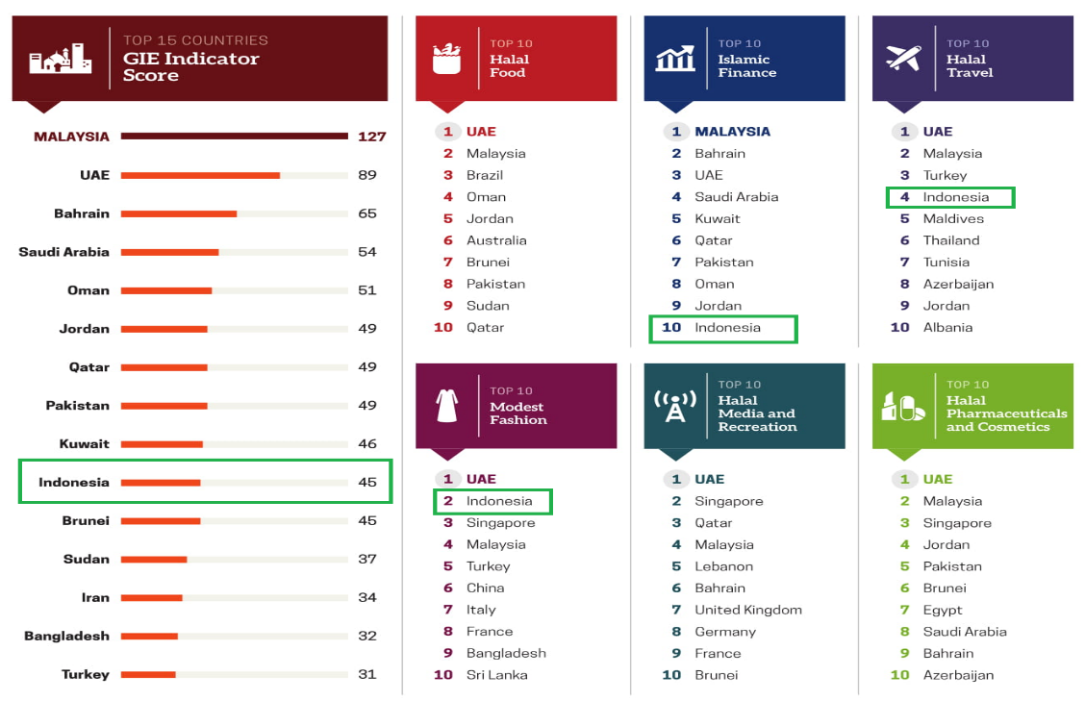
Figure 1. Players of Global Halal Market
Source: Thomson Reuters, 2018

Indonesia has the biggest number of muslim population in the world. With 85% percentage of total population, more than 200 million of the citizens are muslim. According to Thomson Reuters (2018), Indonesia spent the biggest expenditure on halal food amounted to USD 170 billion in 2017. Sadly, Indonesia is not on the top 10 list of halal food producer.
As the biggest muslim population country, halal product exports reaches 21% of total exports overall (Brodjonegoro, 2018). Islamic finance in Indonesia is ranked the 10th. Halal travel is number 4 and Halal Fashion is the second worldwide.
Despite being number 1 in number of population, Indonesia is not number 1 in terms of global halal market. Halal assurance Law was just legalized in 2014. Awareness of halal certificate and halal industry is relatively late compared to the growth of the halal market which has attracted players not only from muslim majority populated countries.

Motivation of the Study
A study by Ab Talib et al. (2016) conclude that a highly institutionalised Halal industry covering government support will encourage the development. Government good will in implementing halal certification could lead to positive acceptance from Muslim consumers. If the government fails at giving assurance about halal certification, cases such as the misuse by some irresponsible parties will result in losing public trust (Nor Ardyanti et al., 2013).
Soon and Wallace (2017) states that attitude is a significant factor in influencing purchasing intention of Halal food. This research will focus on attitude on those who are educated with Islamic values in a quite significant time.
Tazkia University College of Islamic Economics is chosen as the sample. Tazkia is the pioneer of Islamic Economic Teaching in Indonesia. Started the higher education operation in 2001, Tazkia has experienced 18 years of academic culture and is now entering the 19th year. Tazkia has graduated 2259 alumni from 14 batches and currently has 2003 active students. It is not exaggerated to assume that the students should have good awareness on halal purchasing behaviour. However, objective study has to be done. To be the first player in global halal market, it is just logical that we need people with good awareness, at least starting from halal purchasing behavior.

- Research Question
The main focus of this study is to find out the determinant factors of purchasing behavior among students in STEI Tazkia towards halal food and beverages, halal cosmetics and medicine, halal tourism, and halal finance.

- Literature Review
The Concept of Halal
Halal is a term covering all matters which are not prohibited and are in compliance with Islamic rules (Wilson and Liu, 2010, 2011; Wilson, 2014). Battour and Ismail define the term halal as “the practices or activities allowed by the Islamic teachings” (2015, p. 2). The antonym of halal is the word haram. Halal is defined as the matters not specified by Shari’ah as haram, whereas Haram is defined as the matters specifically indicated by Shari’ah as haram (kuranvehadis.com). The root of halal and haram is Arabic.
In addition to Islam, there are also “the allowed” and “the not allowed” matters in Christianity and Judaism. “Licite and illicite” in French, “lawful and the prohibition, forbidden and unlawful” in English and “tahur and tame” in Hebrew are similar words for terms “Halal” and “Haram” (Erdem, 1997).
The coverage of the term “Halal” is not restricted only for food and beverages (El-Gohary, 2015). Thus, it is an Islamic term which has an overall impact on each and every aspect of a Muslim’s daily life. Quran, the holy scripture of Islam, or the Prophet Mohammad’s (peace be upon him) sayings are considered as the basis for specifying an activity or anything as halal. Therefore, halal and haram are based on the verses of Quran and the sayings of the Prophet. The 168th verse of the Surah Al Baqara, 88th verse of the Surah Al Maidah, 69th verse of the Surah Enfal and 114th verse of the Surah Nahl are the relevant references in this regard. For instance, God shall will in 168th verse of the Surah Al Baqara as following: “O ye people! Eat of what is on earth, lawful and good; and do not follow the footsteps of the Satan, for he is to you an avowed enemy”.

Theory of Consumption in Islam
According to Ayob (2017), principles of consumption in Islam should be in line with Maqasid Syariah, as follow:
- Protection of religion or al- Din.
Allah states in Quran
وَقَٰتِلُواْ فِي سَبِيلِ ٱللَّهِ ٱلَّذِينَ يُقَٰتِلُونَكُمۡ وَلَا تَعۡتَدُوٓاْۚ إِنَّ ٱللَّهَ لَا يُحِبُّ ٱلۡمُعۡتَدِينَ
“Fight in the way of Allah those who fight you but do not transgress. Indeed. Allah does not like transgressors.” (Surah Al-Baqarah, 190)
It was reported in a hadeeth qudsi: “He (who) is nourished with haraam, so how could his du’aa’ be responded to?” The meaning is that it is unlikely that his du’aa’ will be answered.
When providing products and services to Muslim consumers, vendors are expected to ensure that their products and services are Halal and does not endanger their faith
- Protection of human life and progeny.
Allah states in Quran
وَلَا تَقۡتُلُواْ ٱلنَّفۡسَ ٱلَّتِي حَرَّمَ ٱللَّهُ إِلَّا بِٱلۡحَقِّۗ وَمَن قُتِلَ مَظۡلُومٗا فَقَدۡ جَعَلۡنَا لِوَلِيِّهِۦ سُلۡطَٰنٗا فَلَا يُسۡرِف فِّي ٱلۡقَتۡلِۖ إِنَّهُۥ كَانَ مَنصُورٗا
And do not kill the soul which Allah has forbidden, except by right. And whoever is killed unjustly - We have given his heir authority, but let him not exceed limits in [the matter of] taking life. Indeed, he has been supported [by the law]. (Surah Al-Isra‟:33)
In consumer protection context, it refers to the rights of safety and right to get healthy environment from any products and service that might be harmful to consumer.
- Protection of human honour or dignity.
۞وَلَقَدۡ كَرَّمۡنَا بَنِيٓ ءَادَمَ وَحَمَلۡنَٰهُمۡ فِي ٱلۡبَرِّ وَٱلۡبَحۡرِ وَرَزَقۡنَٰهُم مِّنَ ٱلطَّيِّبَٰتِ وَفَضَّلۡنَٰهُمۡ عَلَىٰ كَثِيرٖ مِّمَّنۡ خَلَقۡنَا تَفۡضِيلٗا
And We have certainly honored the children of Adam and carried them on the land and sea and provided for them of the good things and preferred them over much of what We have created, with [definite] preference. (Surah Al-Isra‟:70)
In relation to this verse, human honour is such a gift from Allah. Therefore, everyone has their rights including the honour of consumers and traders in any activities such as in business, travelling and others
- Protection of intellect.
“The search of knowledge is an obligation laid on every Muslim”.
Allah says in Quran:
...ۗ قُلۡ هَلۡ يَسۡتَوِي ٱلَّذِينَ يَعۡلَمُونَ وَٱلَّذِينَ لَا يَعۡلَمُونَۗ ...
Say, "Are those who know equal to those who do not know?" (Surah Az-Zumar:9)
The rights to be informed and to get knowledge about products or services, to have skills in choosing goods or services, as well as to be aware of their rights and responsibilities.
- Protection of wealth or property.
وَلَا تَأۡكُلُوٓاْ أَمۡوَٰلَكُم بَيۡنَكُم بِٱلۡبَٰطِلِ وَتُدۡلُواْ بِهَآ إِلَى ٱلۡحُكَّامِ لِتَأۡكُلُواْ فَرِيقٗا مِّنۡ أَمۡوَٰلِ ٱلنَّاسِ بِٱلۡإِثۡمِ وَأَنتُمۡ تَعۡلَمُونَ
And do not consume one another's wealth unjustly or send it [in bribery] to the rulers in order that [they might aid] you [to] consume a portion of the wealth of the people in sin, while you know [it is unlawful]. (Surah Al-Baqarah:188)
It covers all basic of consumers rights which objectively to prevent the rights of consumers from any malpractices from traders or suppliers either in goods or services.

Purchasing Behavior: Determinant Factors
Religiosity
Religion have great influence on the purchase decision of Muslim consumers (Syah Alam et.al, 2011). Religion obligation has significant influence on attitude, including consumption (Jaffara and Musa, 2016).
Culture
The host culture influence consumption behaviour (Bonne et.al, 2007). Culture also give certain impact to product labelling (Jamal and Sharifuddin, 2015).
Knowledge
Ishak et.al (2016) add that understanding and awareness of consumer are among determinant factor to purchase halal product. Other than halal awareness (Aziz and Vui, 2012; Nor Sara et al., 2014), halal certification (Aziz and Vui, 2012), and knowledge about product ingredients (Mohani et al., 2009; Nor Sara et al., 2014) also have positive effect for customers to purchase halal products.
Psychology
For certain customers, halal represents hygiene, cleanliness, safety and health (Mathew et, al, 2014; Aziz and Yui, 2012; Rezai et.al, 2012; and Golnaz et.al 2010). Bonne et all (2007) stated that trust and values influence consumers purchasing behaviour towards halal product. For the producers, to be halal certified is important to ensure the trust from the potential buyers (Aziz and Vui, 2012).
Products without a recognised Halal logo, products from non-Muslim countries, lack of information on ingredients may affect the buying decision negatively (Rezai et al., 2012). Less public information sharing may impact consumers decision to purchase (Tieman, 2007).
Social
Subjective norm, including norms embraced by family and friends influence buying intention (Lada el.al, 2009). Marketing promotion and branding (Aziz and Vui, 2012) are also important.
Functional factors
Vermeir and Verbeke (2004) in their research conclude that access to halal product is important in supporting intention or motivation to buy halal product. The quality of the product as represented by identity of the manufacturer, product label, the appearance of the physical product and packaging as well country of origin are significant in influencing halal perception (Ishak et.al, 2016).

- Data and Method
Sampling
The sampling method is random sampling and the number is determined using Slovin method:
$$n=\frac{N}{1+{Ne}^{2}}$$
Where:
n: Number of respondents
N: Population Size
e: sampling error
Given that the number of active students is 2003, so the minimum sample used is:
$$\frac{2003}{1+(2003 ×0{.1}^{2})}=95.25$$

Currently, the data collected has exceeded the minimum. 299 data collected already.
Data and Data Collection
Data used in this study is mainly primary data. The primary data is collected through questionnaire distribution.
Research Method
This research will explore relationship between religiosity, culture, knowledge, understanding on maqasid, psychological, social, and functional factors towards purchasing behaviour of students in STEI Tazkia. As all variables are latent, Structured Equation Model will be employed to analyse the data.

- Bibliography
Ab Talib, M.S., Md. Sawari, S.S., Abdul Hamid, A.B. and Ai Chin, T. (2016), “Emerging Halal food market: an institutional theory of Halal certificate implementation”, Management Research Review, Vol. 39 No. 9, pp. 987-997.
Ayob. 2017. “Consumer Protection In Islam: An Overview.” Malaysian Journal Of Consumer And Family Economics. Vol 20 Ed 20.
Aziz, Y.A. and Vui, C.N. (2012), “The role of Halal awareness and Halal certification in influencing non-Muslim’s purchase intention”, 3rd International Conference on Business and Economic Research, Bandung.
Bonne, K., Vermeir, I., Bergeaud-Blackler, F. and Verbeke, W. (2007), “Determinants of Halal meat consumption in France”, British Food Journal, Vol. 109, No. 5, pp. 367-386.
Brodjonegoro, Bambang P.S. 2018. “Mengawal Indonesia Sebagai Pusat Halal Value Chain Dunia – Perspektif Industri Makanan dan Minuman.” Komite Nasional keuangan Syariah. Presented at National Seminar KNKS Halal Value Chain Forum. Jakarta, 18 Desember 2018
Golnaz, R., *Zainalabidin, M., Mad Nasir, S. and Eddie Chiew, F.C. 2010. “Non-Muslims’ awareness of Halal principles and related food products in Malaysia.” International Food Research Journal. 17: 667-674 (2010).
Halal Journal. 2006. "Halal Journal Awards 2006 - the judges comments". http://www.halaljournal.comartman/publish/article_799.shtml
International Trade Centre. 2015. From Niche to Mainstream: Halal Goes Global. Switzerland: International Trade Centre.
Jaffara, Mariatul Aida and Musa, Rosidah. 2016. “Determinants of Attitude and Intention towards Islamic Financing Adoption among Non-Users.” Procedia Economics and Finance 37 ( 2016 ) 227 – 233
Jamal, Ahmad & Sharifuddin, Juwaidah, 2015. "Perceived value and perceived usefulness of halal labeling: The role of religion and culture," Journal of Business Research, Elsevier, vol. 68(5), pages 933-941.
Jan Mei Soon, Carol Wallace, (2017) "Application of theory of planned behaviour in purchasing intention and consumption of Halal food", Nutrition & Food Science, Vol. 47 Issue: 5, pp.635-647
Lada, Suddin, et.al, (2009) "Predicting intention to choose halal products using theory of reasoned action", International Journal of Islamic and Middle Eastern Finance and Management, Vol. 2 Issue: 1, pp.66-76,
Mohani, A., Hashanah, I., Haslina, H. and Juliana, J. (2009), “Consumer decision making process in shopping for Halal food in Malaysia”, China-USA Business Review, Vol. 8, No. 9, pp. 40-47.
Nanji, Noor. 2018. London Has Potential to Lead in Islamic Finance, Says IDB President. The National. March 06, 2018.
Nor Ardyanti, B.A., Tunku Nashril, B.T.A. and Yahya, M.H.B.A. (2013), “A study on halal food awareness among Muslim customers in Klang Valley”, 4th International Conference on Business and Economic Research (4th ICBER 2013) Proceeding, Golden Flower Hotel, Bandung, 4-5 March, pp. 1073-1087.
Nor Sara, N.M.Y., Wan Edura, W.R., Noradifia, M.A. and Norhidayah, M.R. (2014), “Muslim’s purchase intention towards non-Muslim’s Halal packaged food manufacturer”, Procedia – Social and Behavioural Sciences, Vol. 130, pp. 145-154.
Office for National Statistics. 2011. 2011 Census: Population Estimates for the United Kingdom, 27 March 2011. https://webarchive.nationalarchives.gov.uk/20160108132257/
Pratiwi, Fuji. 2016. Belajar Halal dari Thailand. https://www.republika.co.id/berita/koran/teraju/16/01/27/o1lt0h1-belajar-halal-dari-thailand
Rezai, G., Mohamed, Z.A. and Shamsudin, M.N. (2012), “Non-Muslim consumers’ understanding of Halal principles in Malaysia”, Journal of Islamic Marketing, Vol. 3 No. 1, pp. 35-46.
Suraiya Ishak, Abd Hair Awang, Mohd Yusof Hussain, Zaimah Ramli, Sarmila Md Sum, Suhana Saad, Azima Abd Manaf, (2016) "A study on the mediating role of halal perception: determinants and consequence reflections", Journal of Islamic Marketing, Vol. 7 Issue: 3, pp.288-302
Syed Shah Alam, Rohani Mohd, Badrul Hisham, (2011) "Is religiosity an important determinant on Muslim consumer behaviour in Malaysia?", Journal of Islamic Marketing, Vol. 2 Issue: 1, pp.83-96
Thomson Reuters. 2018. “The State of the Global Islamic Economy Report 2018/2019” Dubai: Dubai the Capital of Islamic Economy.
Tieman, M. (2007), “Effective Halal supply chains: the way forward’”, The Halal Journal, Kaseh Dia Sdn Bhd, Kuala Lumpur, pp. 52-54.
US Department of State. 2006. ”Thailand”. https://www.state.gov/j/drl/rls/irf/2006/71359.htm
Vermeir, I. and Verbeke, W. (2004), “Sustainable food consumption: exploring the consumer ‘attitude behavioral intention’ gap”, Journal of Agricultural and Environmental Ethics, Vol. 19, No. 2,pp. 169-194.
Wells, J.D., Valacich, J.S., Hess, T.J. (2011), “What signal are you sending? How website quality influences perceptions of product quality and purchase intentions”, MIS Quaterly, Vol. 35 No. 2, pp. 373-396.

